Secret-Key Encryption Lab

NAME: JASHWANTH REDDY GANGULA

SUID: 646254141

1 Overview  
In this lab we gain hands on experience on secret key encryption, specifically on encryption algorithms, encryption modes, paddings and initial vector(V) . We will be able to use tools and write programs to encrypt and decrypt messages.

2 Lab Tasks  
2.1 Task1: Encryption using different ciphers and modes  
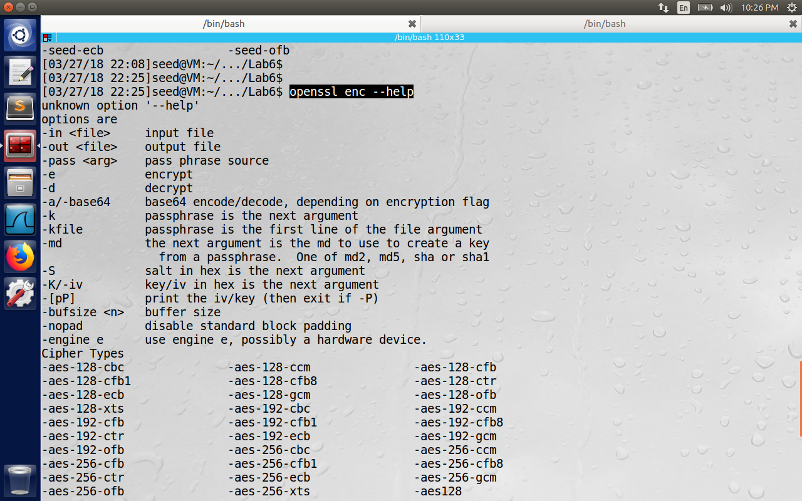

In the above image we see that command should be of the type “openssl enc ciphertype –e –in plain.txt –out cipher.bin \ -K 00112233445566778889aabbccddeeff \ -iv 0102030405060708”.

Here we have to give –in <file> for the input file, -out <file> for the output file, -e/-d (either to encrypt or decrypt a file), -K/-iv is the initialization vector in hexadecimal format, -[pP] is used to print the iv/key. Some of the Cipher types in the above figure are of the format <Algorithm>-<key_size>-<encryption mode>. In class we have discussed about often used modes like ECB(Electronic Codebook), Cipher Block Chaining(CBC), Cipher Feedback(CFB), Output Feedback(OFB) and Counter Mode(CTR Nance).

This is the content of plain.txt file we will encrypt.

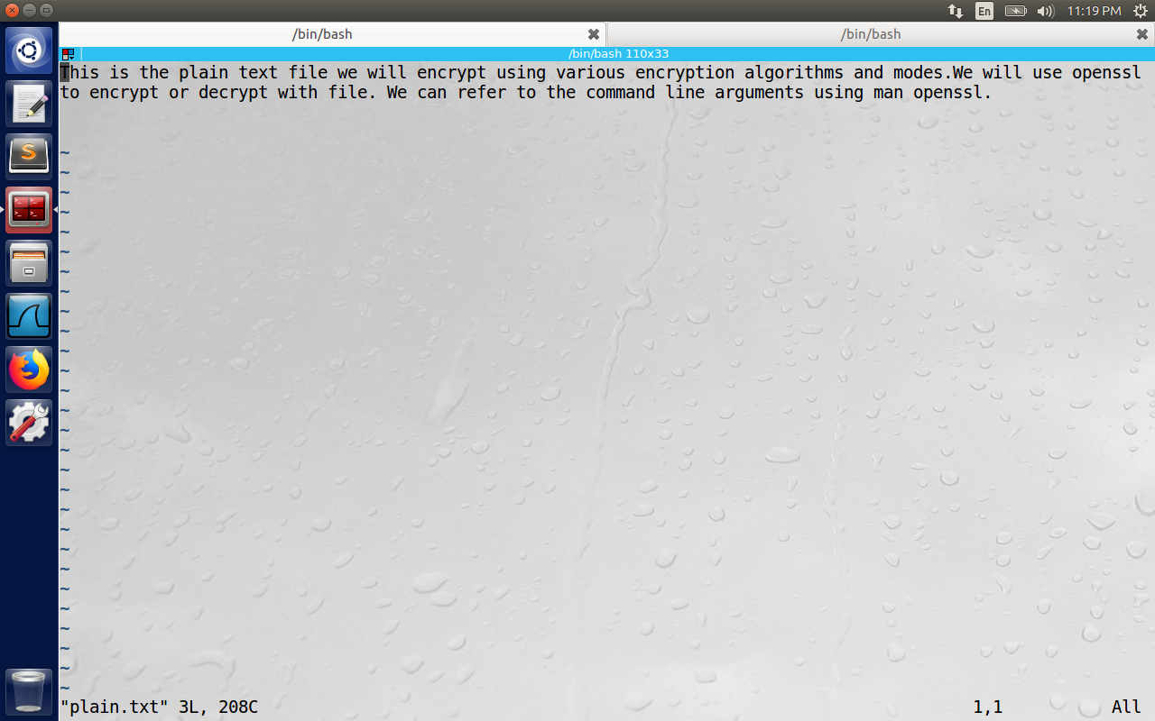

**1) AES –128–cbc**

Encryption:

Here we will use Cipher type as AES, Key size = 128 bit (16 bytes), encryption mode as Cipher Block Chaining. Here key value used is 00001111222233334444555566667777 (128 bit) and initialization vector used is 01020304050607087889aabbccddeeff. The output file cipher_aes_128_cbc.bin is opened using bless hex editor.

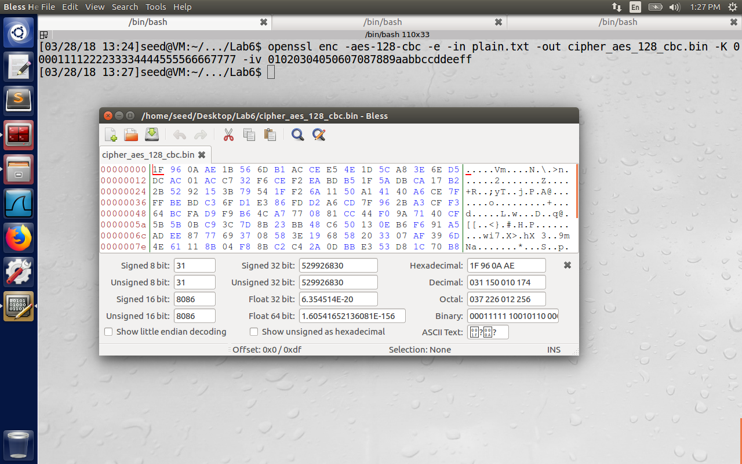

Decryption:

The decrypted file contains the below text, and we are able to extract the content by decrypting the cipher file with the same key and iv. (The command is highlighted in black as shown below.)

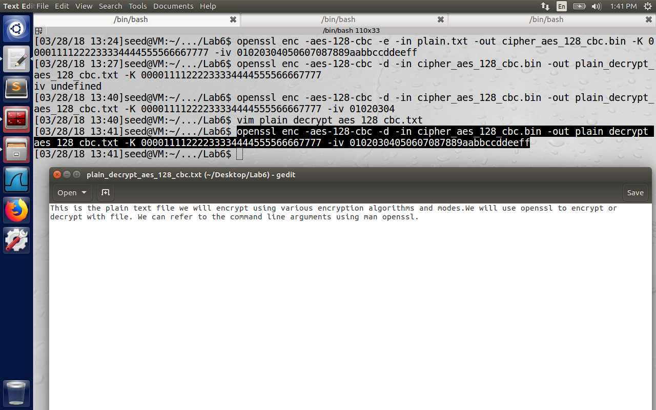

**2) AES-128-cfc**

Encryption:

Here we will use Cipher type as AES, Key size = 128 bit (16 bytes), encryption mode as Cipher Feedback (CFB), which is a self-synchronizing stream cipher.   
Her key value used is 00001111222233334444555566667777 and initialization vector used is 0102030405060708. The output file is cipher_aes_128_cfc.bin.

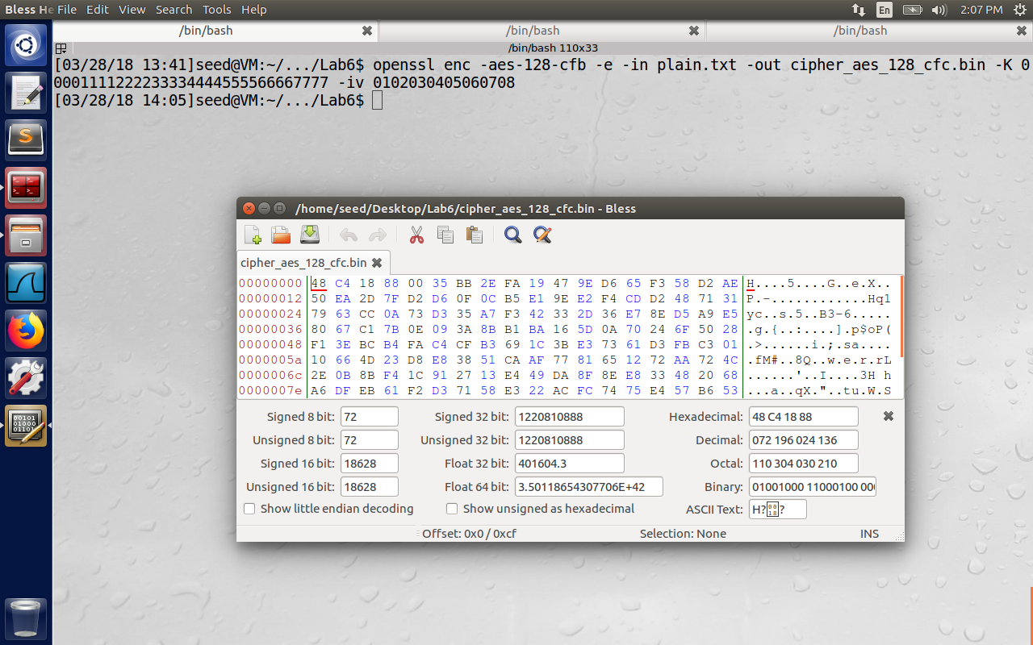

Decryption: (Command highlighted in the image below)  
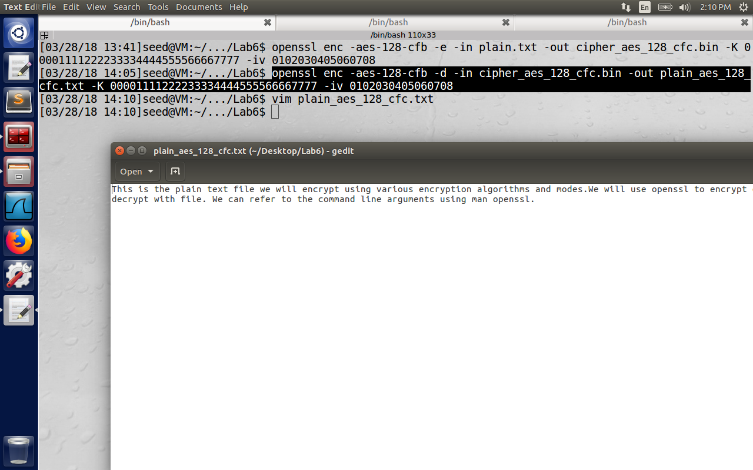

**3)AES-128-ofb**

Encryption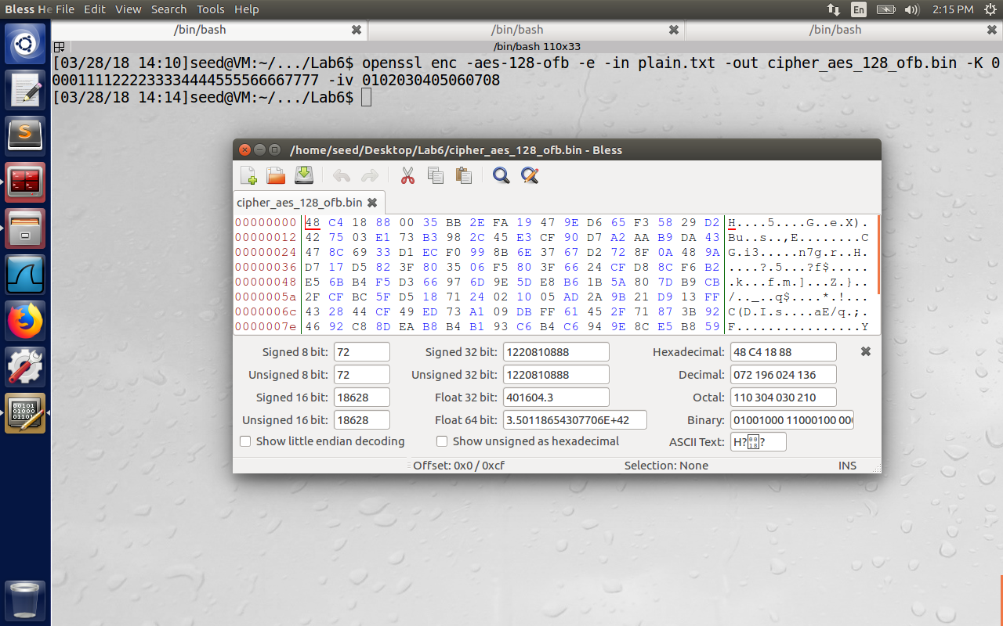

Decryption:  
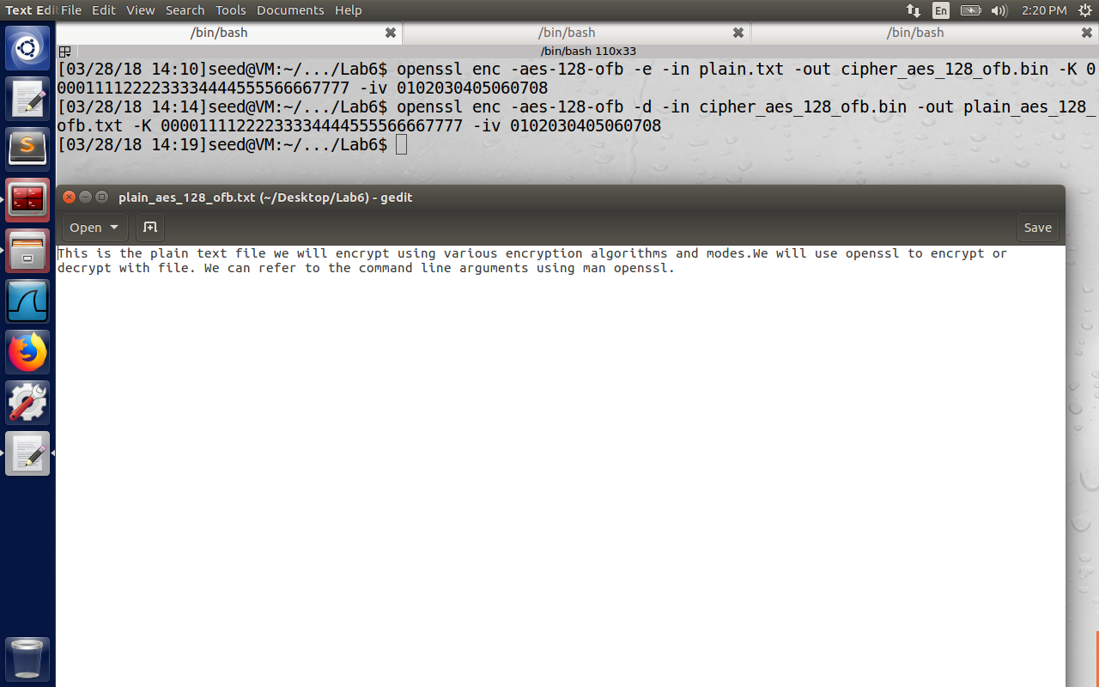

The same can be repeated for BF (blowfish) encryption which is symmetric encryption with 128-bit key for modes cbc, cfb, ofb.

4)BF-128-CBC  
Encryption & Decryption:  
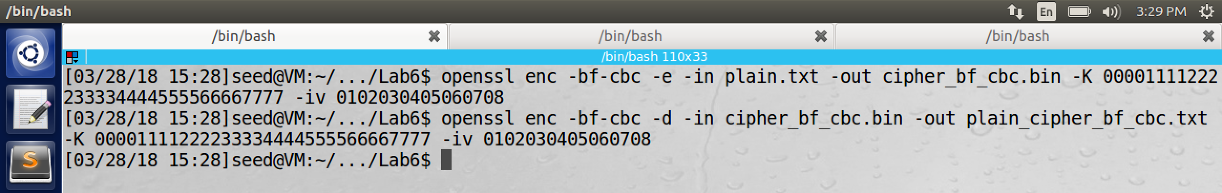

5)BF-128-CFB  
Encryption & Decryption:  
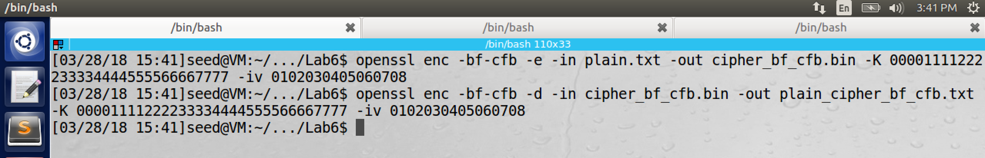

6)BF-128-OFB  
Encryption & Decryption:  
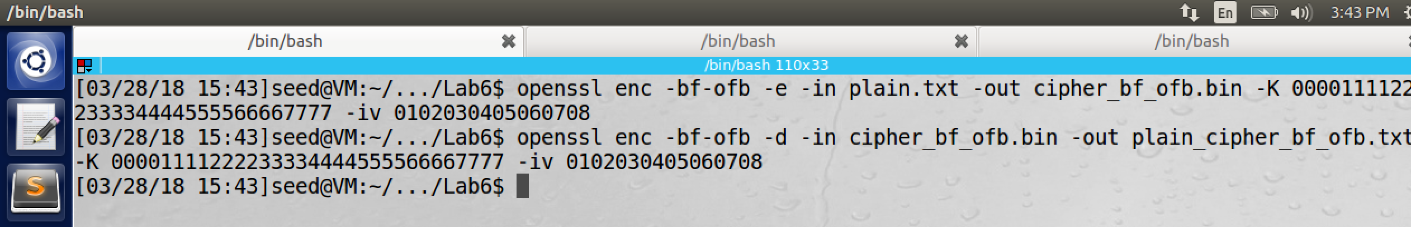

**2.2 Task 2: Encryption Mode – ECB vs. CBC**

The image below is from <http://www.cis.syr.edu/~wedu/seed/Labs_16.04/Crypto/Crypto_Encryption/> (the bitmap file is converted to jpg file to be viewed in the word document).



We need to encrypt this image file using Electronic Code Book(ECB) and CBC (Cipher Block Chaining) modes. For the bmp file, the first 54 bytes contain the header information about the picture, we have to set it correctly, so that encrypted file will be viewed as .bmp file. For that we have to replace the header of the encrypted picture with the original picture.

The command used to encrypt the original image is “openssl –aes-128-ecb –e –in pic_original.bmp –out pic_ecb_encrypted.bmp –K 00001111222233334444555566667777”. The timestamp of encrypted image is   
highlighted in the image below. (at 16:11PM)

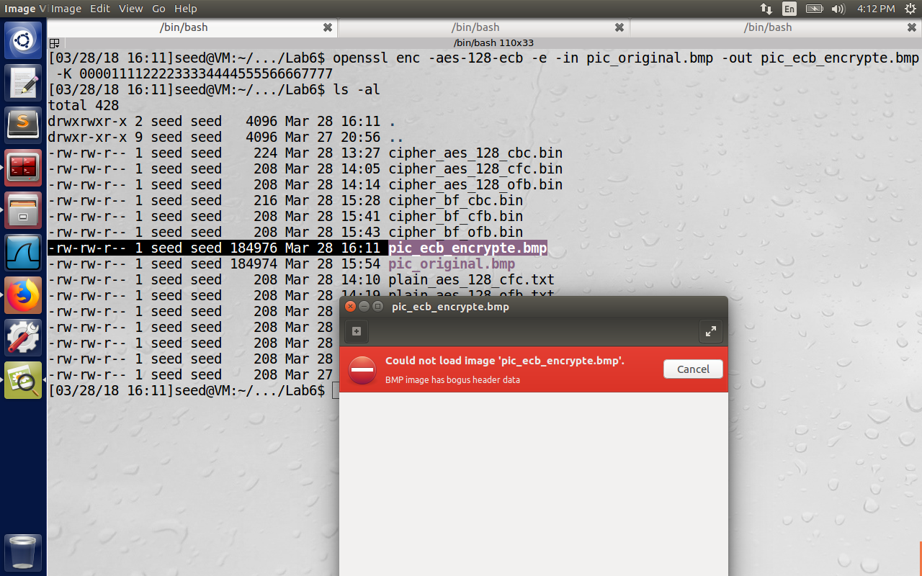

Please observe that in the image above, the encrypted image was unable to be viewed by the image application and the error thrown is (in red color) BMP image has bogus header data.

For reconstructing the header of the encrypted file, we issue the commands

1)head –c 54 pic_original.bmp > header

2)tail –c +55 pic_ecb_encrypte.bmp > body  
3)cat header body > pic_ecb_new.bmp.  
The first command copies first 54 bytes from the original image to file named header. The second command copies everything starting from 55th byte of encrypted image file to body. The third command combines the original header and the encrypted body to a new bmp file and hence it was able to be opened by the application.

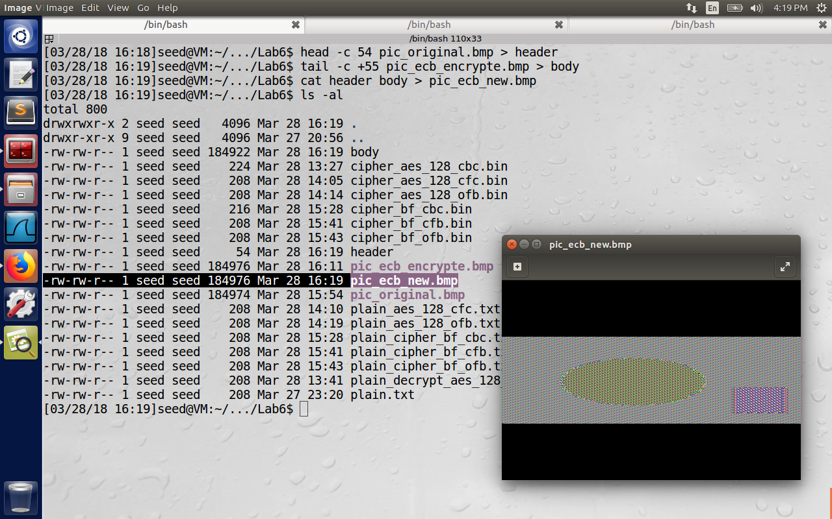

CBC Mode:

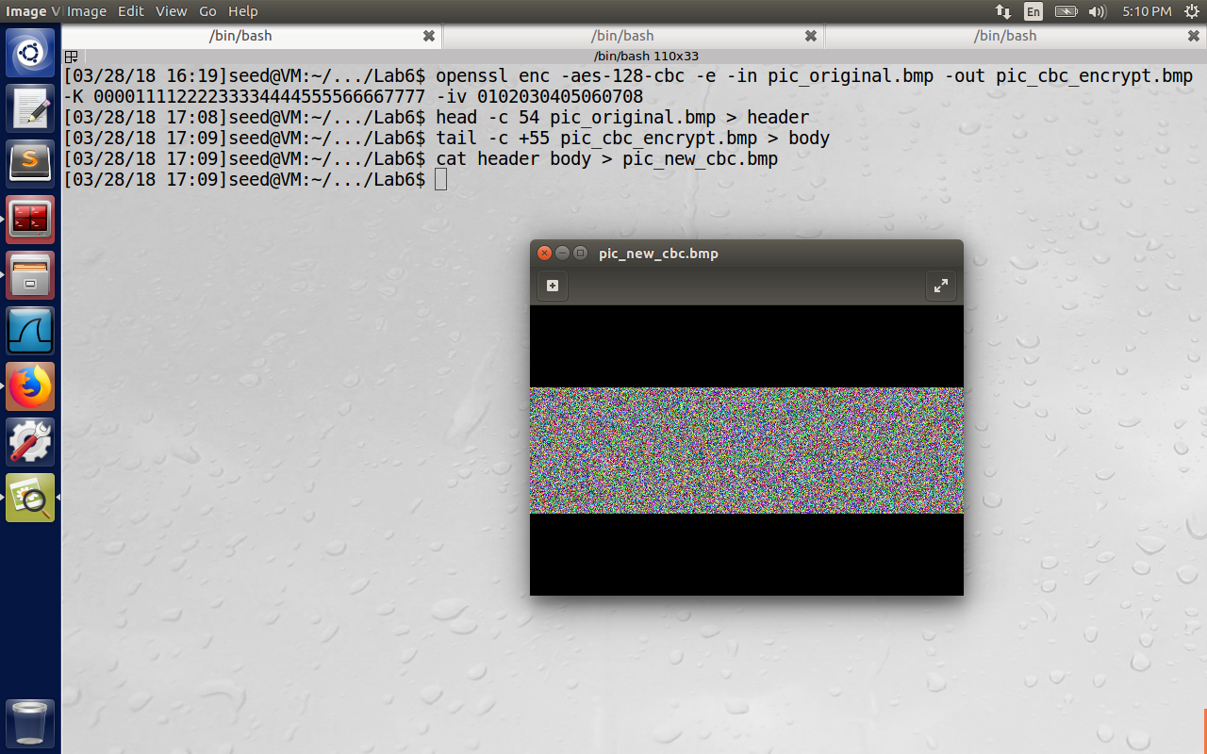

Difference observed between EBC and CBC:

In the EBC mode, the key remains the same. Since we are dealing with pixels, most of the values remains same throughout 128-bit block. Hence the information can be easily perceived i.e., all the borders of the image, coloring might be changed, but not secure enough. In case of CBC, the output of one block is exored (exor operation) with the plain text of next block before sending to the encryption, so even if the plain text remain the same, single bit difference will produce output that is completely different, as we can see in the image above.

**2.3 Task 3: Encryption Mode – Corrupted Cipher Text**

The below screenshot is the original text.

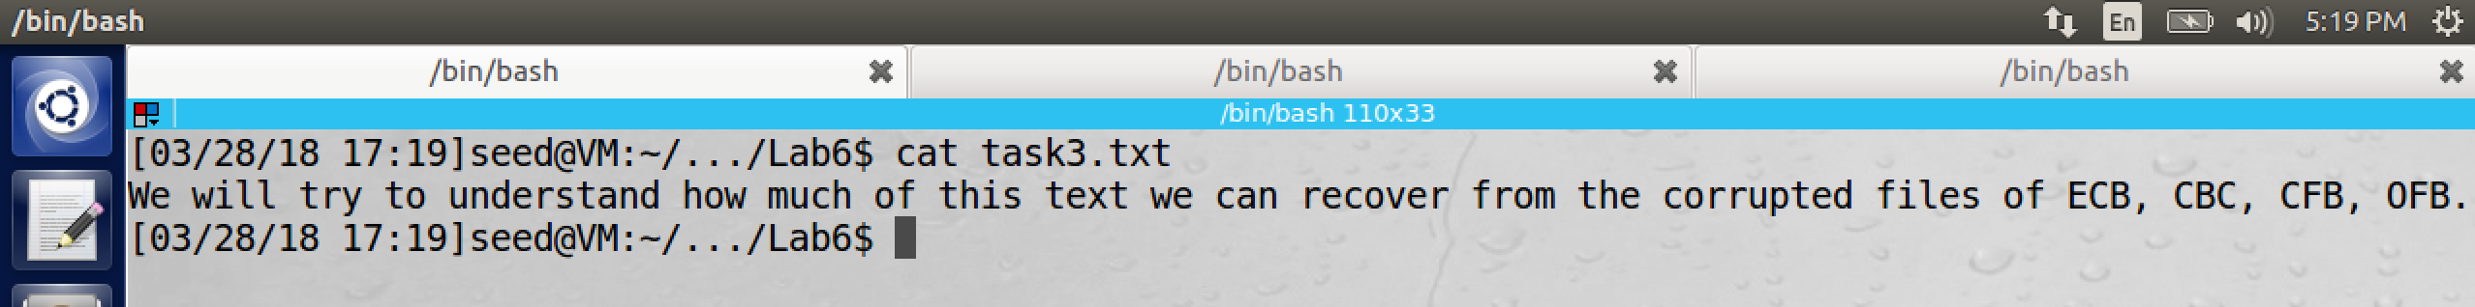

**Encryption Mode: ECB**  
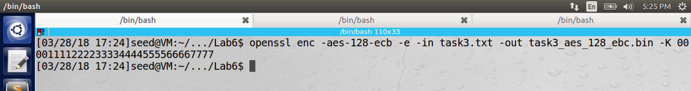

We will change the 30th byte from 2F to 2E and try to decrypt the file.

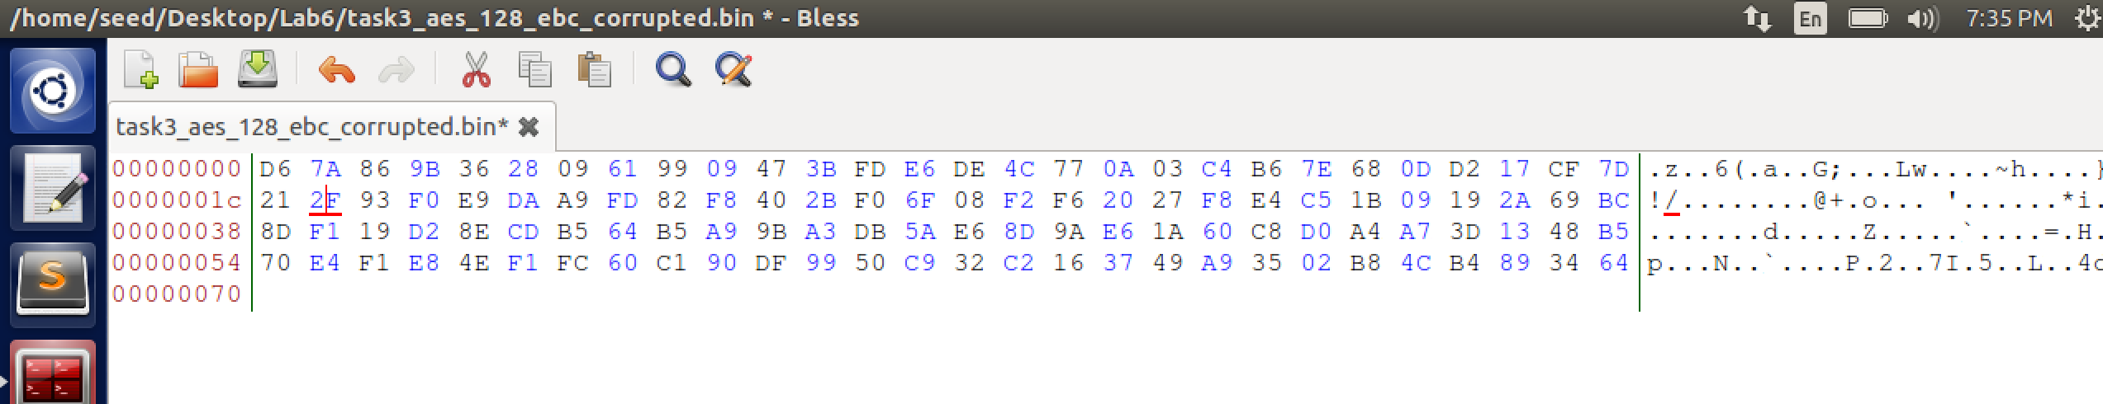

Now we have corrupted the 30th byte of the task3_aes_128_ebc_corrupted.bin file using the hex editor and decrypt the corrupted bin file to get the task3_ecb_corrupted.txt file. If we inspect it we observe that first 16 bytes are recovered, next 16 bytes are corrupted and the rest of the content is also fine (only 2nd block is corrupted because 30th byte is in second block.)

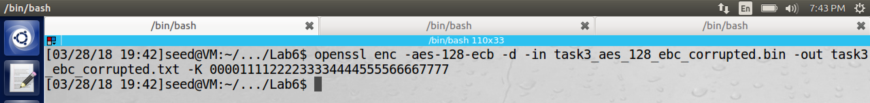

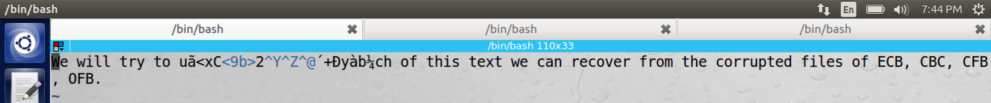

**Encryption Mode: CBC**  
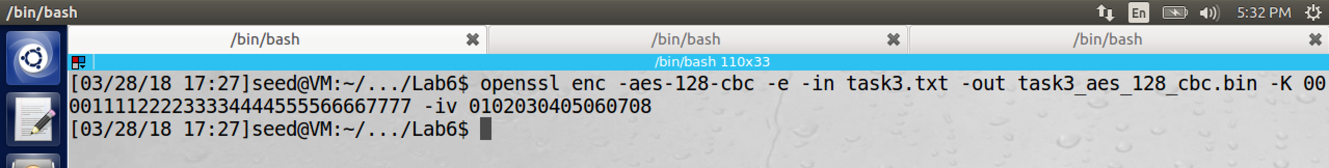

Original File:

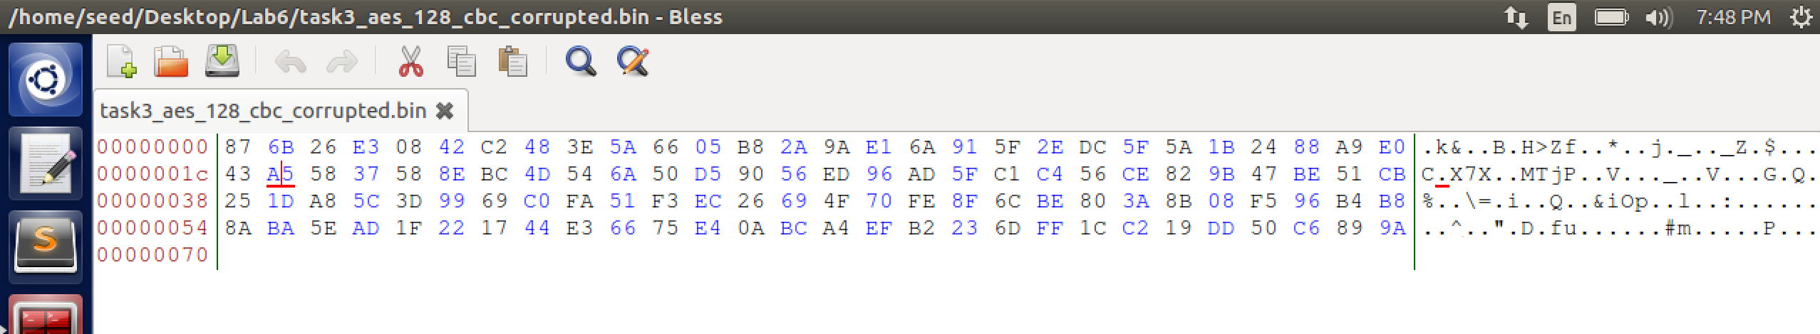

Corrupted File (30th byte changed from A5 to AB):

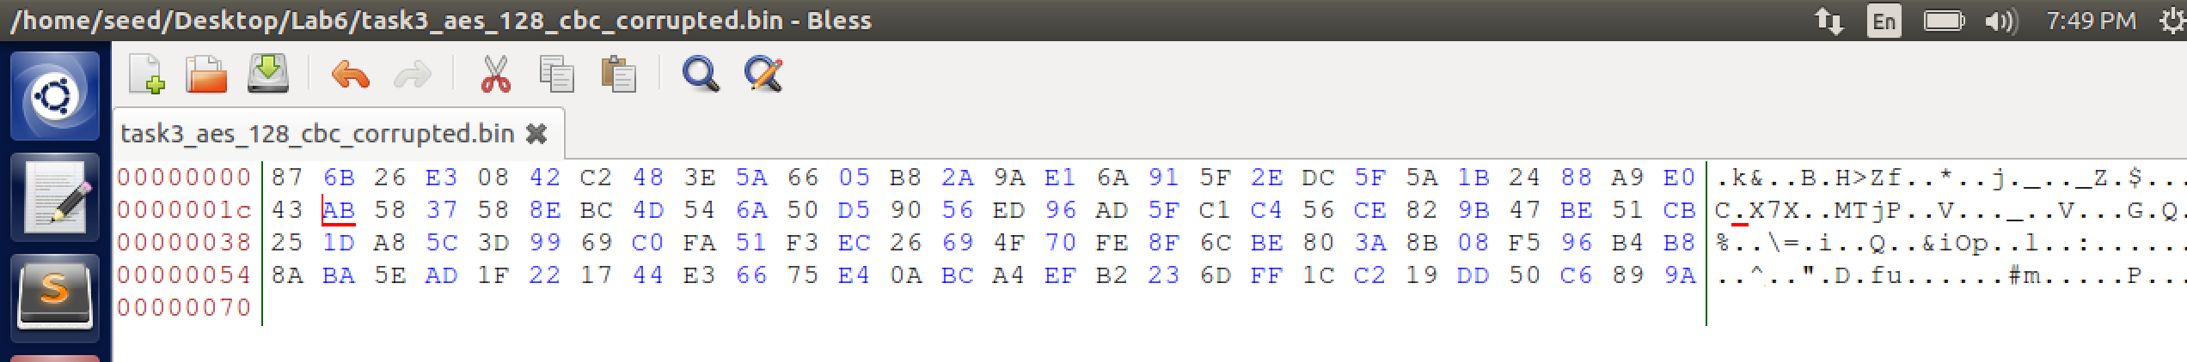

CBC Decryption Diagram:

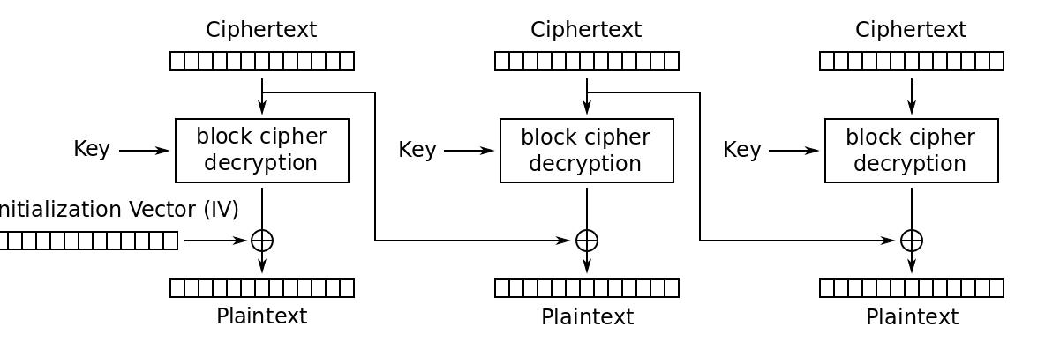

Decrypt the corrupted file now:

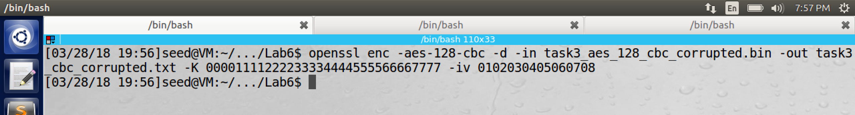

We observe that entire 2nd block is corrupted, 1 byte of third block (46th byte to be precise because it is xored with 30th byte of 2nd block) is corrupted and then rest of the content can be recovered.

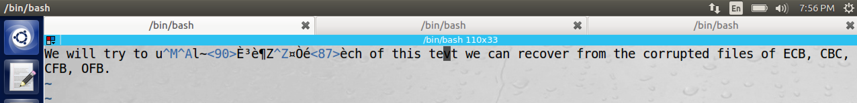

**Encryption Mode: CFB**  
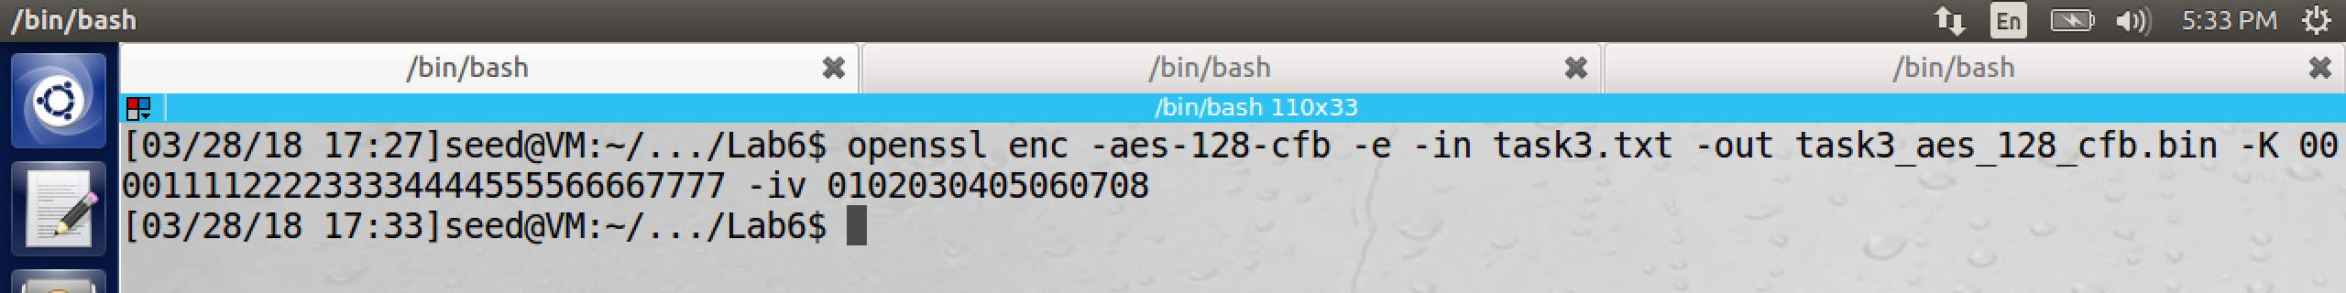

Original File:

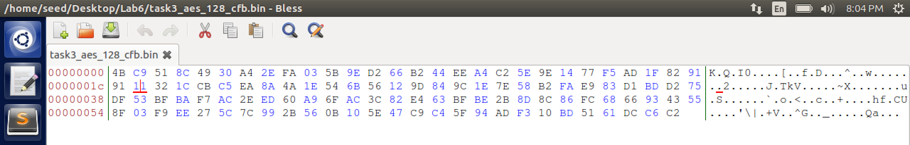

We will modify 30th byte from 11 to 22.  
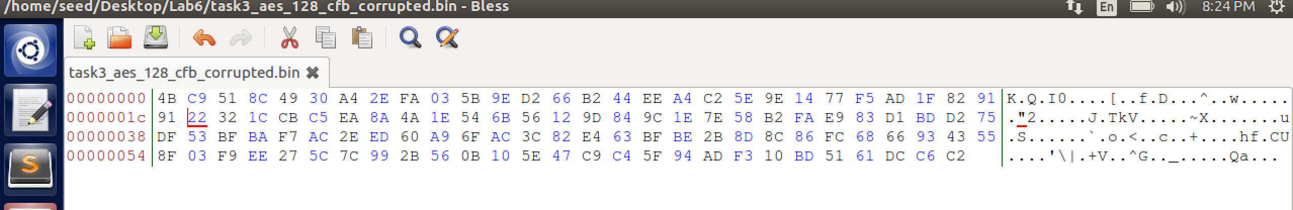

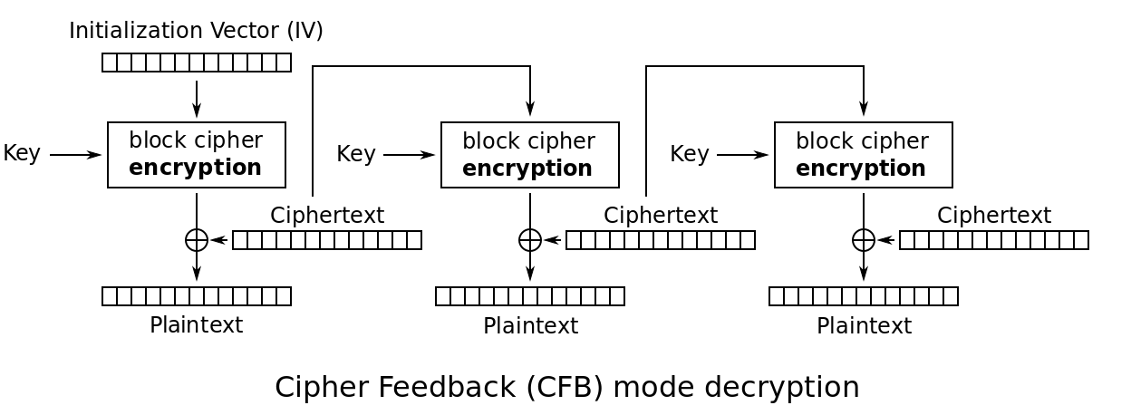

Decrypt the corrupted file now:  
2nd block 1 byte is corrupted, 3st block is completely corrupted. Rest of the content is recovered. (In the decryption diagram above, ciphertext of 1st block is second to be decrypted and then xor is performed with ciphertext of 2nd block, so 1byte of plain text is corrupted, ciphertext of 2nd block is decrypted, so entire plain text of 3rd block is corrupted).



**Encryption Mode: OFB**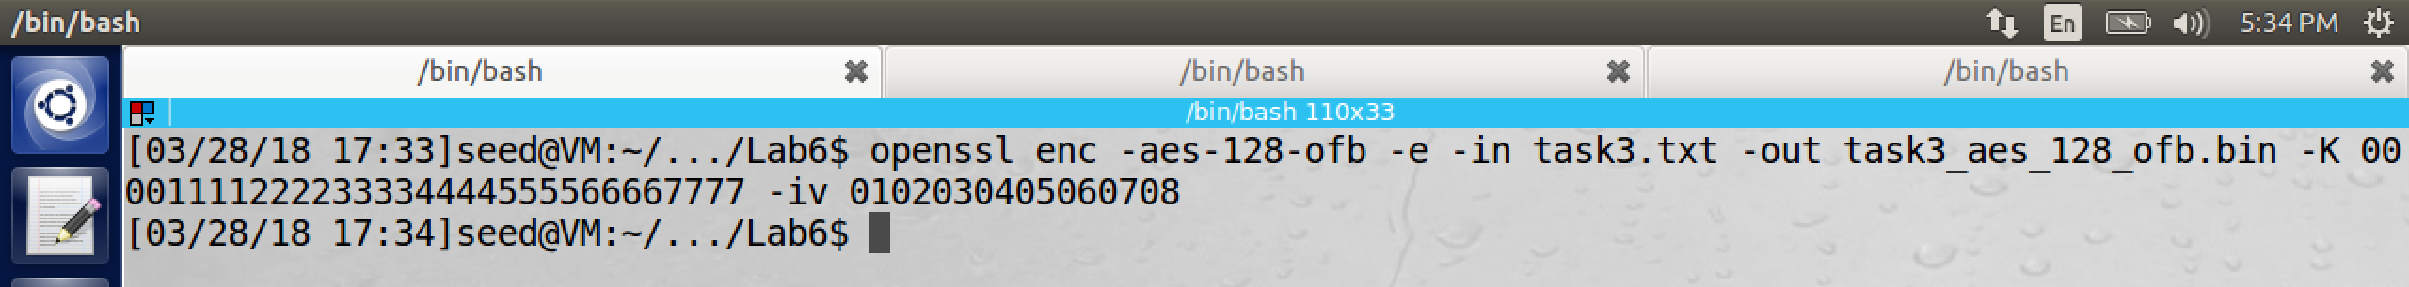

Original File:

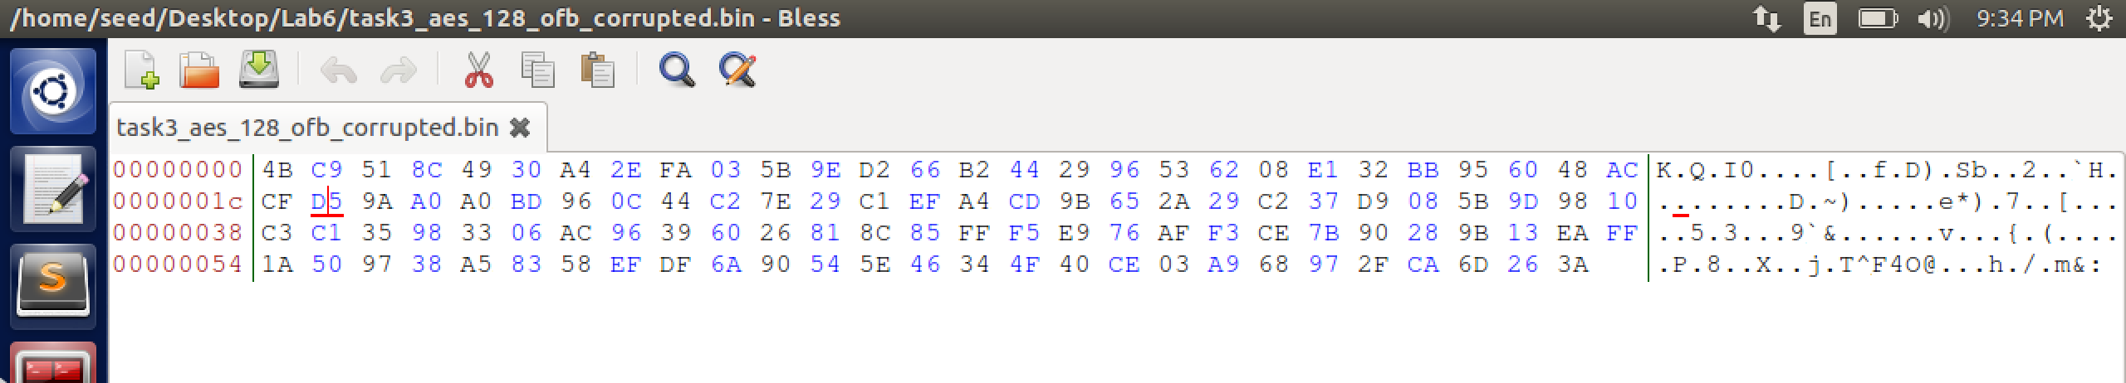

pad

After modifying the 30th byte (from D5 to AA) :  
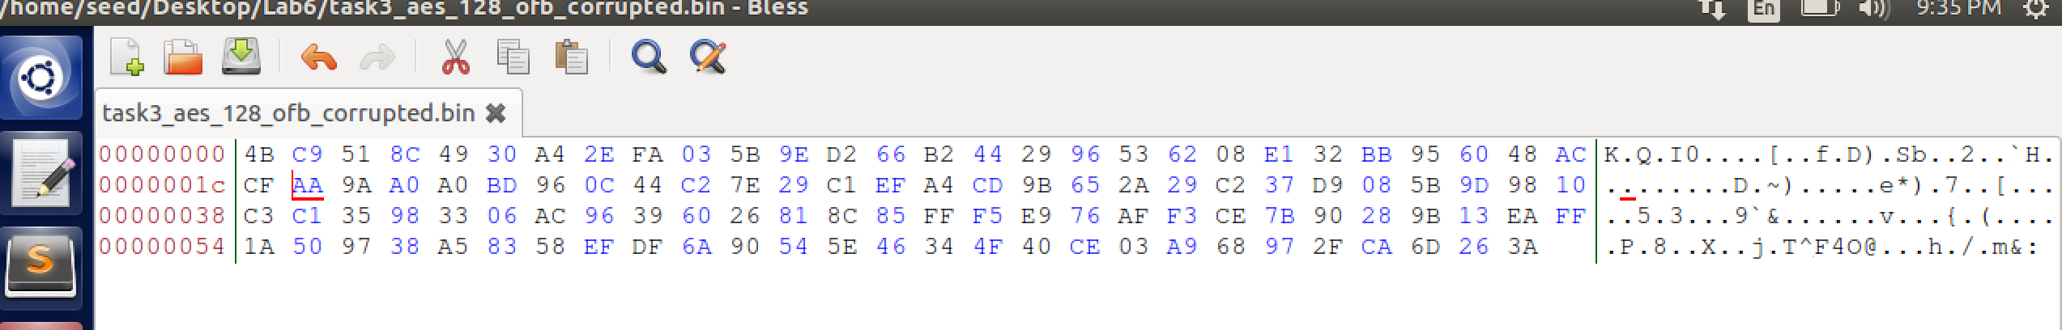

OFB Decryption Diagram:  
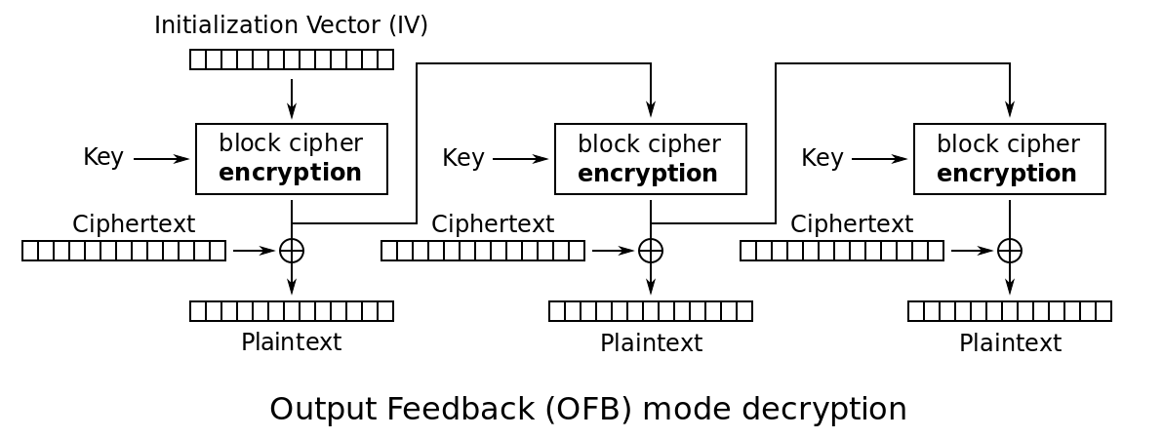

Decrypt the corrupted file now:

1st block is recovered, **1 byte of second block is corrupted**, Rest of the content is recovered after decryption. (Please observe _ character at 30th byte is corrupted, rest of the content is same as original text)

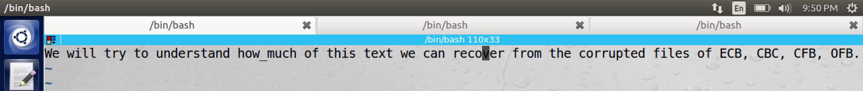

**2.4 Task 4: Padding**When the size of plaintext is not a multiple of the block size, padding is required.

Exercise1:  
openssl uses PKCS5 standard for its padding. We will experiment to figure out the paddings in the AES encryption for text of length 20 and 32 bytes.

In AES-128 each block should be 16 bytes long to encrypt. So any size that is not multiple of 16 is padded accordingly.

Length of the text file below = 20 bytes

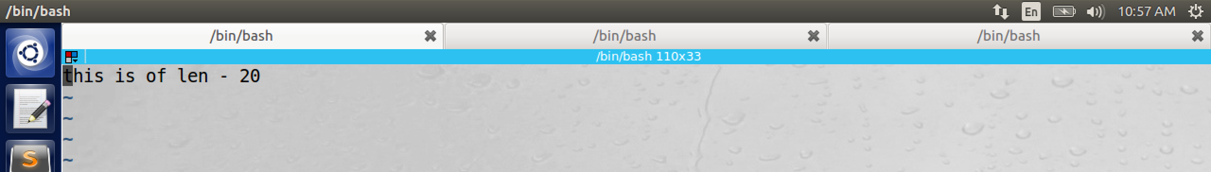

Length of the text file below = 32 bytes

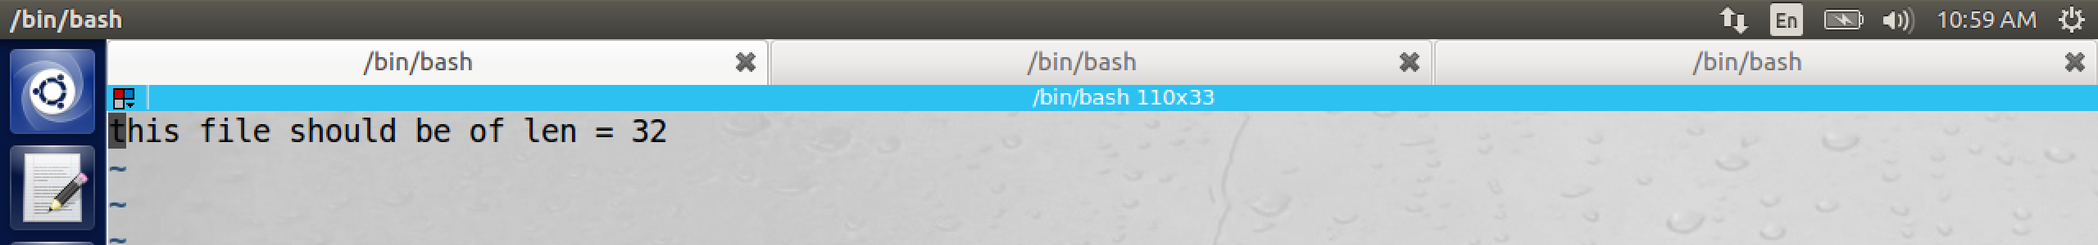

In the image below, we have two files: task4_20bytes.txt, task4_32bytes.txt. Each file is encrypted using the ECB, CBC, CFB and OFB. So there are 8 commands executed in the image.

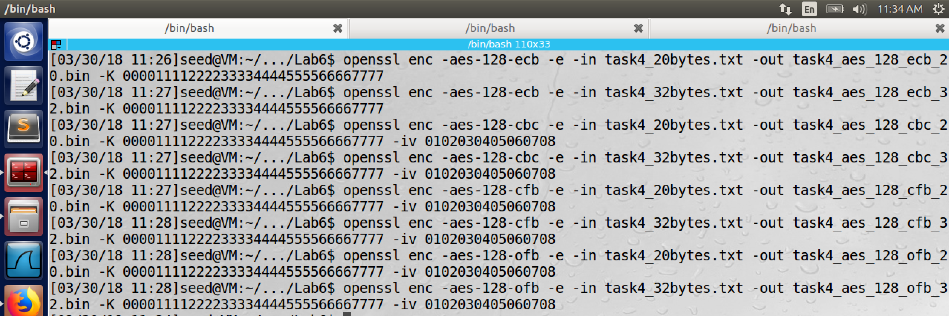

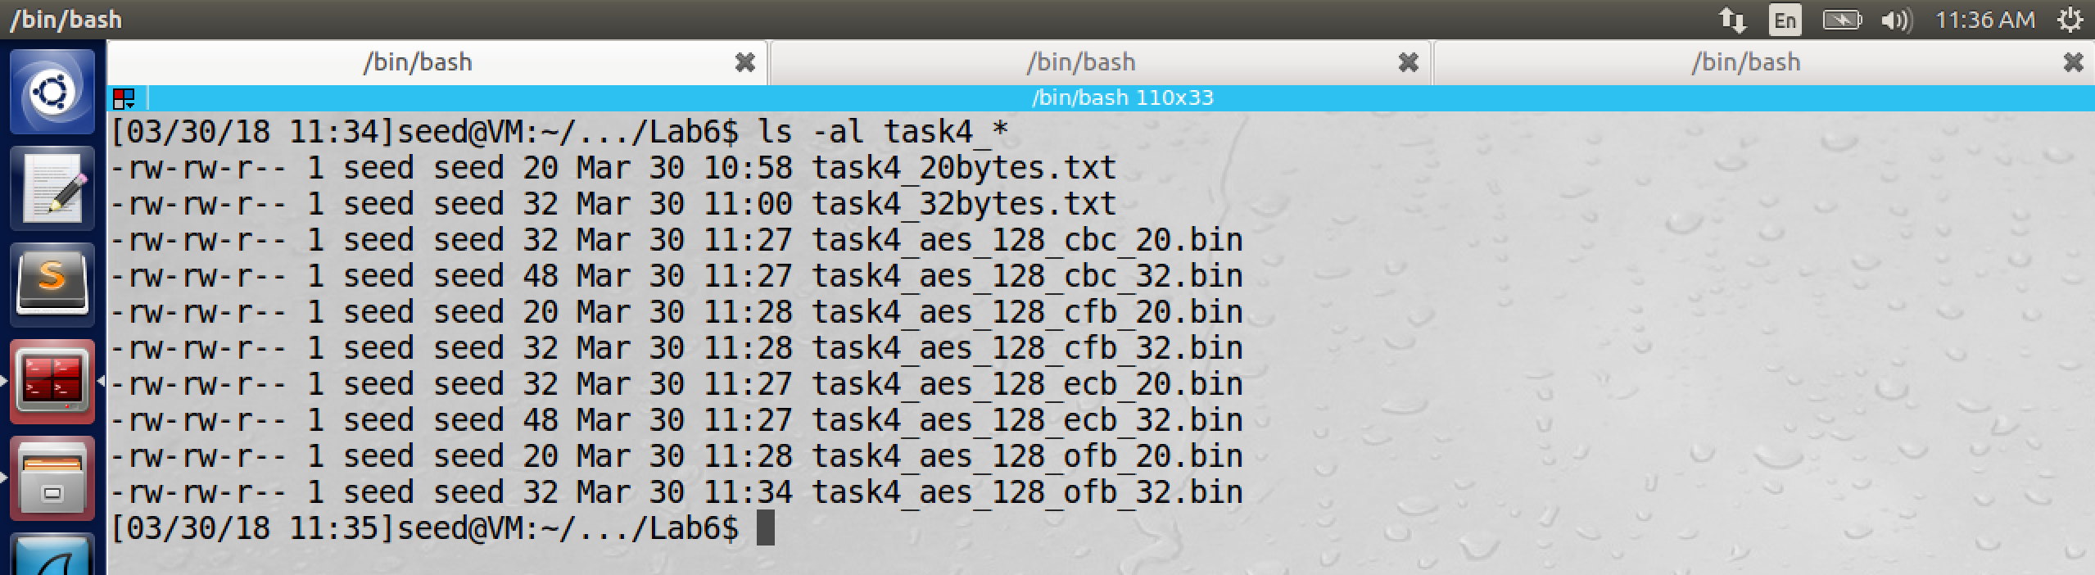

Length of File task4_20bytes.txt = 20 bytes

Length of File task4_32bytes.txt = 32 bytes

CBC Encryption:

Encryption Length of (20-byte size file) task4_aes_128_cbc_20.bin = 32 bytes

Original File = 20 bytes (16 bytes + 4 bytes). Each block in CBC is 16 bytes, second

Block of size 4 bytes is padded with 12 bytes to get 16 bytes. Hence the padding of 12 bytes is done to the original file (20 bytes) to get encrypted file of size 32 bytes.

When we decrypt the encrypted file (of size = 32 bytes) openssl is smart enough to remove the padding before saving it to the decrypted file. In order to see padding in the decrypted file, we will provide the option –nopad and observe the padding.  


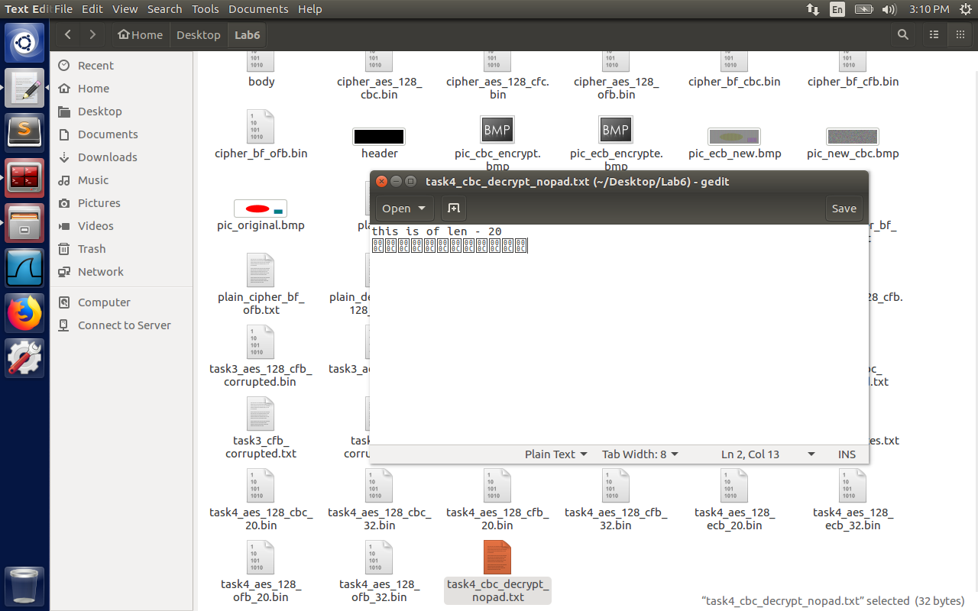

Here in the image above, please see 12 bytes padded to the file task4_cbc_decrypt_nopad.txt containing 32 bytes (if we give –nopad option when decrypting) even though the original plain text is only of 20 bytes.

Encryption Length of (32-byte size original file) task4_aes_128_cbc_32.bin = 48 bytes.

CFB Encryption:

Encryption Length of (20 bytes size file) task4_aes_128_cfb_20.bin = 20 bytes  
Encryption Length of (20 bytes size file) task4_aes_128_cfb_32.bin = 32 bytes

ECB Encryption:  
Encryption Length of (20 bytes size file) task4_aes_128_ecb_20.bin = 32 bytes  
Encryption Length of (32 bytes size file) task4_aes_128_ecb_32.bin = 48 bytes

OFB Encryption:

Encryption Length of (20 bytes size file) task4_aes_128_ofb_20.bin = 20 bytes  
Encryption Length of (20 bytes size file) task4_aes_128_ofb_32.bin = 32 bytes

From the data above, we can infer that no padding was done for the modes CFB and OFB because they come under the category of **stream ciphers**.

Please observe here that as soon as a character of plain text is available, ciphertext corresponding to that character is generated. OFB is completely parallel i.e., it will just wait for stream of characters to produce the output.  
  
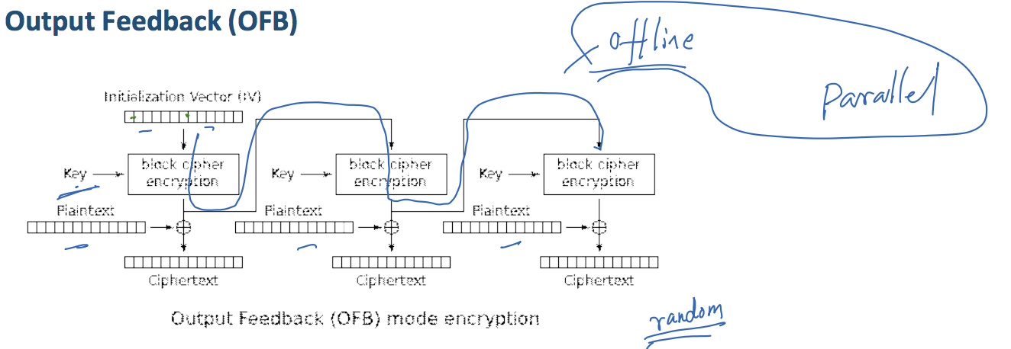  
  
ECB and CBC encryption are **block based** ciphers, hence padding was done for these modes.  
In the diagram of CBC shown below, it expects each plaintext of size 16 byte block. Hence padding is needed for ECB and CBC.

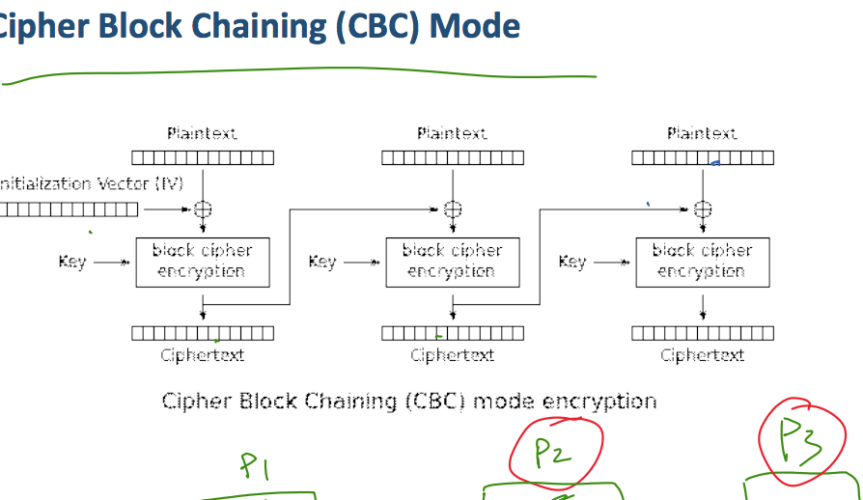

**2.5 Task 5: Pseudo Random Number Generation**

In many cases, encryption keys are not provided by users, but generated inside the software. They should be crypto random, otherwise user can guess them, and the security of the system is compromised. In the following tasks, we will look into some of the secure ways to generate pseudo random numbers that are good for security purposes.

**Task 5.A: Measure the Entropy of Kernel**Software might not be good at generating randomness, so it has to resort to physical world to gain the randomness. Some events can be finishing time of block device requests, inter-key press timings, mouse movements etc.  
Randomness is measured using entropy, It simply means how many bits of random numbers the system currently has. As we keep on moving the mouse and type some command before executing the “cat /proc/sys/kernel/random/entropy_avail” value increases with randomness like moving mouse and giving inputs through keyboard. As the system goes idle with less randomness of mouse, keyboard, interrupts the value also keeps on going down as in the image below.

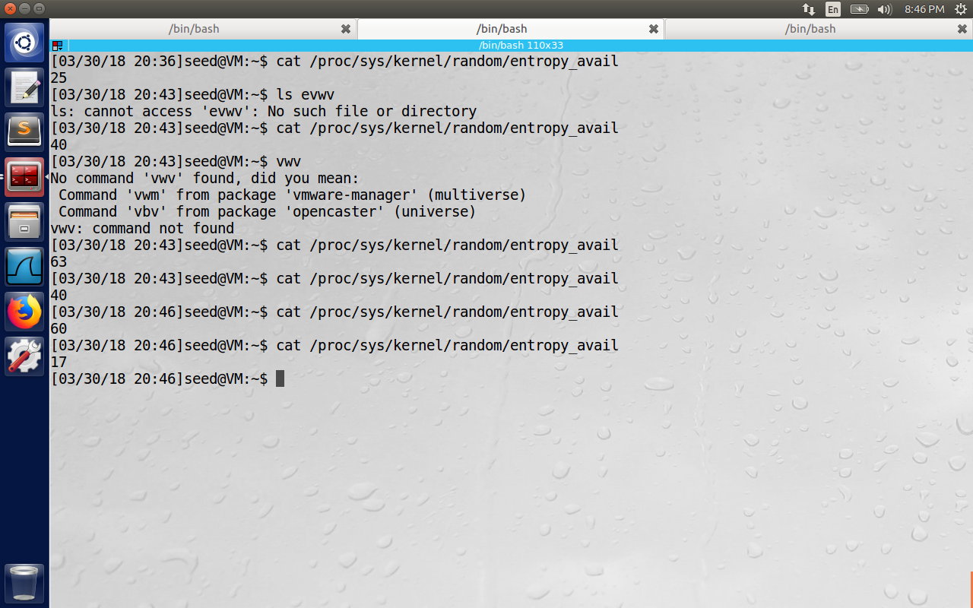

**Task 5.B: Get Pseudo Random Numbers from /dev/random**

Here we have two terminals. On the left terminal, we keep on running the command “head –c 16 /dev/random | hexdump” until it blocks, on the right terminal we keep on running the command ‘cat /proc/sys/kernel/random/entropy_avail”. When the letft command blocks for randomness, we observe value of 0 for entropy on the right side. This is short lived, and with new input commands or the mouse movements, randomness is again generated.

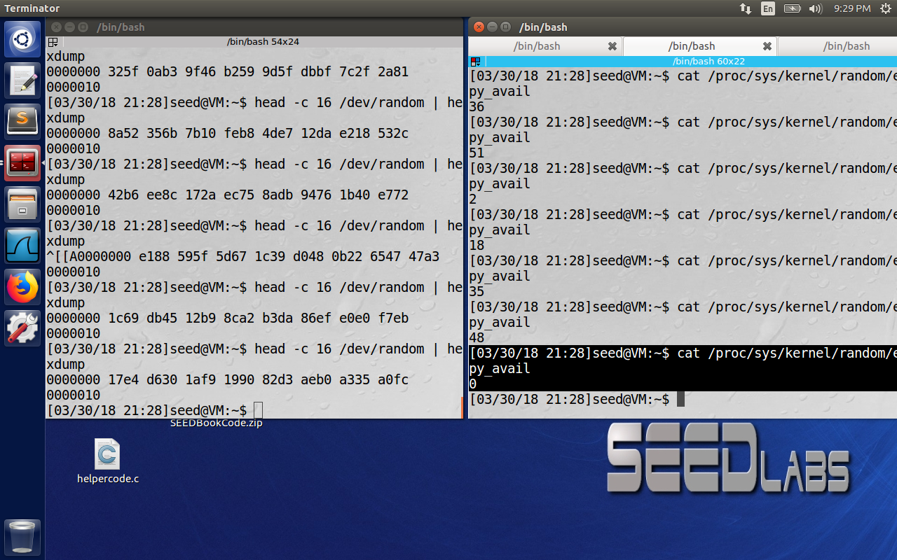

**Task 5.C: Get Random Numbers from /dev/urandom**/dev/urandom device doesn’t block even if the entropy of the pool runs low. /dev/urandom tries to reseed when new random data is available, It is recommend to use /dev/urandom because /dev/random may lead to denial of service attacks. With /dev/urandom it was not blocked even after running multiple iterations.

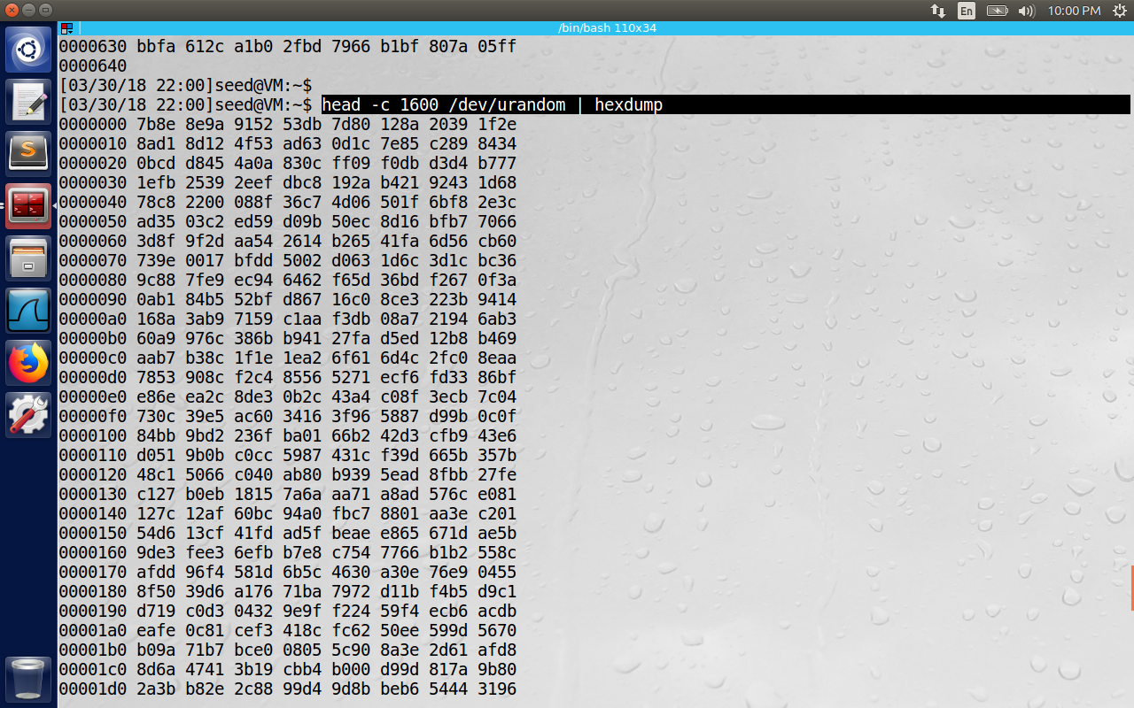

**2.6 Task 6: Programming using the Crypto Library**

In this task, we are given a plaintext and ciphertext, and we are using aes-128-cbc to generate ciphertext from plaintext. Also we are told that initialization vectors are zero. (-iv argument in openssl enc command). Another clue is that the key used to encrypt the plain text is an English word shorter than 16 characters. Since the key has less than 16 bytes, space characters are appended to the end of word to form 128 bits. We have to write a program to find this key.

Program Output: The secret key in our example is “median”

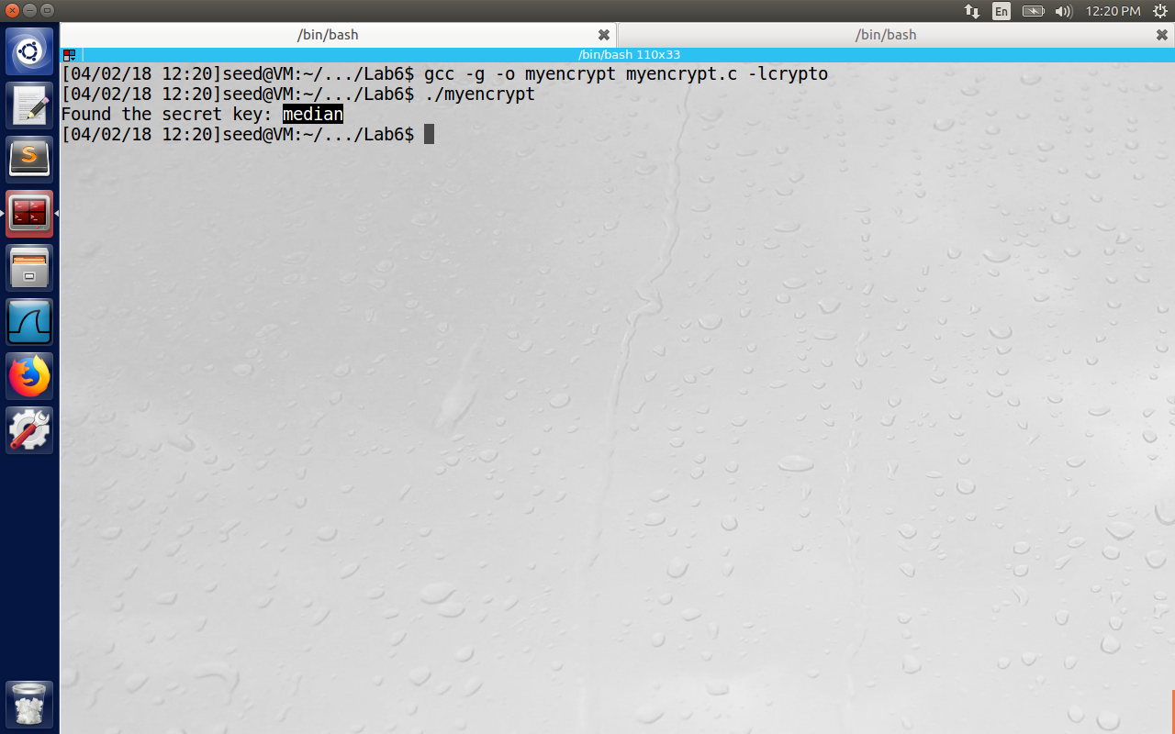

We write the output to a file output_encrypted.txt with each key and its corresponding encrypted string as below.

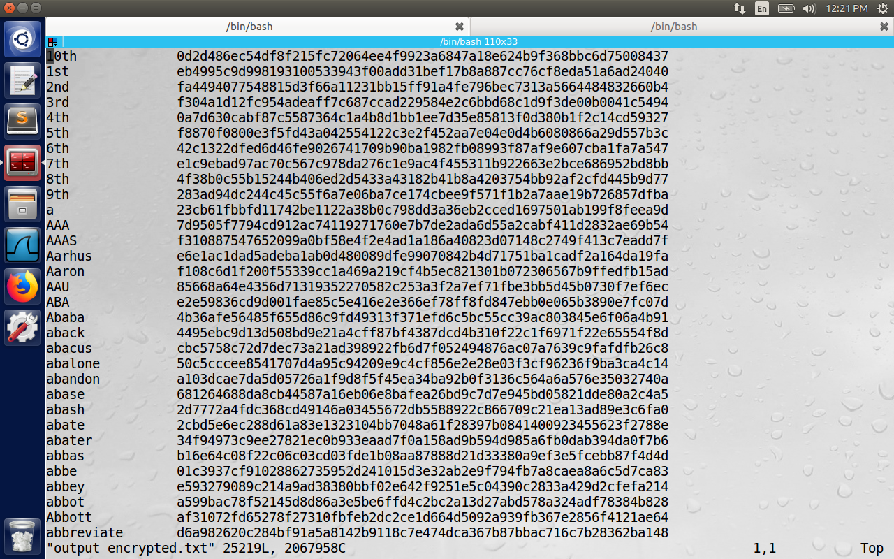

Actual Program:

#include<stdio.h>

#include<string.h>

#include<stdlib.h>

#include<openssl/evp.h>

void pad_with_spaces(char* singleword, int len) {

int curlen = strlen(singleword);

while (curlen < len) {

singleword[curlen] = ' ';

curlen++;

}

singleword[len] = '\0';

}

/*One problem I found out is that we need to pass unsigned char *buf (not char *buf) because

otherwise each character is considered signed and hex digits are mostly printed as fffff... */

void print_result_output_file(char singleword[], unsigned char *buf, int len, FILE* outputList) {

for (int i = 0; i < 16; i++) {

fprintf(outputList, "%c", singleword[i]);

}

/* Add a space between key and encrypted string */

fprintf(outputList, "%c", ' ');

for (int i = 0; i < len; i++) {

fprintf(outputList, "%02x", buf[i]);

}

/* Add an end of file for each pair of key and encrypted string */

fprintf(outputList, "%c", '\n');

}

int main() {

int encryptp = 1;

// use aes-128-cbc to generate ciphertext from plaintext

unsigned char key[] = "00112233445566778899aabbccddeeff";

//unsigned char iv[] = "0102030405060708";

unsigned char iv[16] = {0}; //"0000000000000000" ; // "0102030405060708";

/* for (int i = 0; i < 16; i++) {

iv[i] = 0x00;

} */

/* Don't set key or IV right away ; we want to check lengths */

EVP_CIPHER_CTX ctx;

EVP_CIPHER_CTX_init(&ctx);

EVP_CipherInit_ex(&ctx, EVP_aes_128_cbc(), NULL, NULL, NULL, encryptp);

OPENSSL_assert(EVP_CIPHER_CTX_key_length(&ctx) == 16);

OPENSSL_assert(EVP_CIPHER_CTX_iv_length(&ctx) == 16);

FILE *wordsList, *outputList;

wordsList = fopen("words.txt", "r");

outputList = fopen("output_encrypted.txt", "a+");

if (wordsList < 0) {

perror("Error ");

}

char inptext[] = "This is a top secret.";

// printf("Plain string is: %s and length = %d\n", inptext, strlen(inptext));

char ciphertext[] = "8d20e5056a8d24d0462ce74e4904c1b513e10d1df4a2ef2ad4540fae1ca0aaf9";

// printf("Cipher string is: %s and length = %d\n", ciphertext, strlen(ciphertext));

FILE* output;

unsigned char singleword[16];

int count = 0;

int templen = 0;

unsigned char outbuf[1024 + EVP_MAX_BLOCK_LENGTH];

// memset(&outbuf, 0, sizeof(outbuf));

int outlen, tmplen;

// printf("Before While Plain string is: %s and length = %d\n", inptext, strlen(inptext));

while ((fgets(singleword, 16, wordsList) != NULL) ) {

count++;

/* Since the words.txt ends with \n for each line, we replace that '\n' with '\0' to end that string */

singleword[strlen(singleword)-1] = '\0';

// printf("Len of string is %d\n", strlen(singleword));

if (strlen(singleword) < 16) {

pad_with_spaces(singleword, 16);

}

for(int i = 0; i < strlen(inptext); i++) {

printf("%c ", inptext[i]);

}

// printf("\nBefore EncryptInit String is %s , len of inptext is %d\n",inptext, strlen(inptext));

EVP_EncryptInit_ex(&ctx, EVP_aes_128_cbc(), NULL, singleword, iv);

// printf("String is %s , len of inptext is %d\n",inptext, strlen(inptext));

// Here I am hardcoding the inptext string. need to debug why when inptext is given as

// input it is producing outlen as zero

if (!EVP_CipherUpdate(&ctx, outbuf, &outlen, "This is a top secret.", 21)) {

// if (!EVP_EncryptUpdate(&ctx, outbuf, &outlen, inptext, strlen(inptext))) {

/* Error */

EVP_CIPHER_CTX_cleanup(&ctx);

return 0;

}

// printf("Outlen Before final is %d\n", outlen);

/* Clean up any last bytes left in the output buffer */

if (!EVP_CipherFinal_ex(&ctx, outbuf+outlen, &templen)) {

// if (!EVP_EncryptFinal_ex(&ctx, outbuf+outlen, &templen)) {

/* Error */

EVP_CIPHER_CTX_cleanup(&ctx);

return 0;

}

// printf("Outlen is %d\n", outlen);

// printf("templen is %d\n", templen);

outlen += templen;

/* We create double the size of outbuf because for every character

in outbuf we have 2 hexadecimal characters in buf_hex_encrypt */

char buf_hex_encrypt[2*outlen + 1];

char *buf_operate = buf_hex_encrypt;

for (int i = 0; i < outlen; i++) {

buf_operate += sprintf(buf_operate, "%02x",outbuf[i]);

}

/* End the string with \0 value */

*(buf_operate+1) = '\0';

// printf("Key is %s\n", singleword);

// printf("Outlen is %d\n", outlen);

if (strcmp(buf_hex_encrypt, ciphertext) == 0 ) {

printf("Found the secret key: %s\n", singleword);

}

print_result_output_file(singleword, outbuf, outlen, outputList);

memset(singleword, 0, sizeof(singleword));

}

/* else { }*/

EVP_CIPHER_CTX_cleanup(&ctx);

fclose(wordsList);

fclose(outputList);

// perror("Closed successfully");

return 0;

}